|  |
| --- |
| **Test Plan** |

|  |
| --- |
| Test Plan for: Pharmacy department of DIU |

|  |
| --- |
| Version History |

|  |  |  |  |  |
| --- | --- | --- | --- | --- |
| Version | Date | Change | Author | Approved by |
| 1.0 | 19/08/2023 |  |  |  |
|  |  |  |  |  |

|  |
| --- |
| Abbreviation List |

|  |  |
| --- | --- |
|  | |
| **Term** | **Abbreviation** |
| FR | Functional Acquirement |
| GUI | Graphical User Interface |
| UAT | User Authentication Testing |
| NFR | Non-functional Requirement |
| TBD | To Be Defined |
| PC | Personal Computer |
| HDD | Hard Disk Drive |
| OS | Operating System |

Table of content

1. **Introduction**

# **1/ Introduction**

This project is “pharmacy department website” service system in DIU.

This website will manage Home, about us, Admission, Student, faculty member, contact, apply now, apply online, undergraduate, graduate, tuition fees, eligibility, scholarship, recent notice, recent events sections, also GUI operation)

# **2/Reference**

|  |  |
| --- | --- |
| **Ref. No** | **Document Title** |
| 1.0 | Project Development plan for (Pharmacy Department DIU)  **https://docs.google.com/spreadsheets/d/1L5uNjCl1zRdsLv3JCUDNif5qa-KsAKE5O1uYk9sHKa0/edit?usp=sharing** |

The following documents are used as sources of information for this test plan:

Note:

The Project will be developed following a clone of Agile based methodology

**3/High Level Test Objective**

Our high-level goals are to check this website for feature improvement, new feature implementation, issue fixing, and further maintenance work. We define the following test objectives:

✦ Ensure the functionality of the application works as expected of Requirement. ✦ Prevent defects and ensure issue fixing.

✦ Make sure that the end result meets the requirements.

✦ Gain the confidence of the user by providing them a quality website

✦ Ensure that it satisfies the Requirement Specification

✦ Gaining confidence in and providing information about the level of quality

# **4/Test Strategy**

#### **Test Strategy**

To ensure the quality of the applications (Pharmacy Department DIU)

project, testing will be conducted based on following approaches:

✦ **Functional Testing Strategies**: Functional testing is conducted after preparing test cases for each functional point.

✦ **Retest Strategies**: After performing UI & functional testing, there may be some issues. After fixing this issue, Application will be retested to confirm fixing issues

#### **5/Test Types**

Following types of testing will be conducted to ensure the quality:

**Functional Testing:**

Functional test will be conducted considering the positive and negative scenario. In this level, to be ensured that target application must meet its Scope Statemen

**GUI Test:**

This testing will cover application’s graphical user interface, to ensure flawless implementation based on UI specification. GUI testing intent to test how the application and the user interact. This includes how the application handles user input and how it displays screen text, images, buttons, menus, dialog boxes, icons, tool bars and more.

|  |  |
| --- | --- |
| Sprint 1 | Pharmacy Department DIU UI for below |
| 1. URL Operation 2. Header operation 3. Slider operation 4. Level Text operation 5. Validation Message operation 6. Spelling Mistake operation 7. Image size operation 8. Logo check operation 9. Connect with us section operation 10. Notice operation 11. Apply online operation 12. Apply Now operation 13. Video play operation 14. Navbar all buttons operation 15. Search operation 16. Sort operation 17. Programs and admission operation 18. Recent event operation 19. Recent notice operation 20. View all notice operation 21. Chatbot operation |
| Note:  Test plan and execution may vary depending on the development progress and release. | |

# **5/Features to be tested**

# **6/Features not to be tested**

Here is the features list which will not be tested. Explain the reason why the features will not be tested.

|  |  |
| --- | --- |
| **Phases** | **Features** |
| Phase-1 | 1. Pixel Perfection 2. Integration Testing 3. Regression Testing |

# **7/Test Estimation**

* + Quality of the Test basis
  + Complexity of the problem domain
  + Requirements for documentation
  + Time pressure
  + Number of defects and the amount of rework required
  + Full regression testing

# **8/Release Procedure**

Step-1: Requirement Analysis and preparing Test Plan.

Step-2: Start Development and make internal release for QA .

Step-3: QA continue test case writing, testing build, retesting and report bugs.

Step-4: Developer completes the rest of development and start fixing current sprint Bugs.

Step-6: Developer completes the rest of development and start fixing current sprint Bugs.

Step-7: If there do not have any blocking issue and bug Severity is low, Application goes release

**9/Test Suspension Criteria**

Testing will be suspended, and QA team will reject the receivables upon the following criteria:

During testing blocking issue is identified

Respective bug is not fixed in dedicated release

Release without release note

**Note:** If any case will happen then QA have to raise issue to respective stakeholders

# **10/Test Acceptance Criteria**

* + Application have covered supported front-end(mobile) required browsers for (Android-Browser) and Back-end (Laptop) only support firefox.
  + Application does not have any blocking issue.

# **11/QA Task List and Testing Process**

* Requirement analysis
* Identify test areas
* Test Case writing on identified test areas
* Prepare Test environment
* Execute Test Cases
* Perform concurrency testing
* Bug reporting/retest
* Deliver Test report
* Perform Test closure activity

**12/Test Environment**

## **Hardware Requirement:**

Laptop (Windows 10,11)

Mobile (Android, Pixel 6A)

**Network Requirement:**

Internet connectivity to Laptop /mobile

## **Tools to be used:**

✦ **Test Case management**: Microsoft Excel

✦ **UI Test Tool**: Lightshot.

✦ **Document Management**: Microsoft Word

|  |  |  |  |  |  |  |
| --- | --- | --- | --- | --- | --- | --- |
| Platform | Browser | Device | OS  Version | Resolution | Browser Version | Comments |
| Mobile | Android-Br  owser | Mobile | 13.1.1 | 1080 x 2400 | Lasted  build |  |
| Windows | Firefox | Laptop | 10,11 | 1366X768 | Lasted  build |  |

13.Schedule

|  |  |  |  |  |  |  |
| --- | --- | --- | --- | --- | --- | --- |
| Sprint | Feature name | Req analysis | Number of test items | Test case design | Internal qa release | Final release |
| Sprint 1 | URL Operation | DONE | 2 | 19/08/2023 |  |  |
| Sprint 1 | Header operation | DONE | 20 | 19/08/2023 |  |  |
| Sprint 1 | Slider operation | DONE | 5 | 19/08/2023 |  |  |
| Sprint 1 | Level Text operation | DONE | 10 | 19/08/2023 |  |  |
| Sprint 1 | Validation Message operation | DONE | 10 | 19/08/2023 |  |  |
| Sprint 1 | 1.Spelling Mistake operation  2.Image size operation  3.Popular Course operation  3.Road map session operation  4.Cross-platform session operation | DONE | 30 | 19/08/2023 |  |  |
| Sprint 1 | 1.Up skill training  2.Cultivate love session  3.Contact session 4.operation  Footer session | DONE | 20 | 19/08/2023 |  |  |

# **14/QA Summary Report**

### To execute the testing identify the required environment. You need to consider hardware, software, device, network, tools and other issues here to prepare the test bed.

# **15/Roles and Responsibilities**

|  |  |
| --- | --- |
| Resource Name | Responsibilities |
| Md. Rijwan Uddin | QA |

# **16/Risk and Contingencies**

#### **Schedule: Testing:**

* Complete Design is not provided yet.
* Any changes to the requirements / scope could affect the test schedule.
* Application may have side effects due to implementation of new features and function enhancement and this may affect the functionality of existing feature due to lack of proper testing time.
* Mitigation can be the proper testing scope, testing time.

#### **Application Risk:**

* + - * Application may behave abnormally, and major functions may not work in
      * non-supported devices/interfaces. Application may also not work unexpectedly in latest browsers for which application is not modified and tested.

**17/Test Exit Criteria**

Testing process of the **Pharmacy dept DIU** application will be ended if following criteria are met:

|  |  |  |  |  |  |
| --- | --- | --- | --- | --- | --- |
| Matric/Attribute | Formula | Objective | | | |
| Sprint Release | Alpha Release | Beta Release | GM  Release |
| Failed Test Cases Percentage | (Number of Failed Tests/Total number of tests executed) X 100 | 30% | 10% | 5% | 0% |
| Blocked Test Cases Percentage | (Number of Blocked Tests/Total number of tests executed) X 100 | 10% | 5% | 0% | 0% |
| Defects Deferred Percentage | (Defects deferred for future releases /Total Defects Reported) X 100 | 30% | 10% | 2% | 0% |
| Blocker Defects Percentage | (Block Severity Defects / Total Defects Reported) X 100 | 2% | 1% | 0% | 0% |
| Critical Defects Percentage | (Critical Defects / Total Defects Reported) X 100 | 0% | 0% | 0% | 0% |
| Major Defects Percentage | (Major Severity Defects / Total Defects Reported) X 100 | 50% | 30% | 20% | 0% |
| Minor Severity Defects Percentage | (Minor Severity Defects / Total Defects Reported) X 100 | 100% | 50% | 30% | 0% |
| Trivial Severity Defects Percentage | (Trivial Severity Defects / Total Defects Reported) X 100 | 100% | 80% | 50% | 0% |

* + - * Major bugs are identified, resolved and retested.
      * All test cases are executed and 100% passed.
      * The pass rate could be negotiated in a release judgement meeting with other stakeholders.
      * esting is ongoing but PM requested to release the system.

# **18/Defect Severity Definition**

|  |  |
| --- | --- |
| Classification | Definition |
| Blocker | Blocker defects are those which blocks to conduct other test cases and need to recover test execution work more than 0.5 man day. |
| Critical | Critical defects are those which results in the failure of the complete software system, of a critical subsystem so that no work or testing can be carried out after the occurrence of the defect. It also applies to data loss failures and with processes that leave inconsistent data stored on the database. |
| Major | Major defects are those which also causes failure of entire or part of system, but there are some processing alternatives which allows further operation of the system. It also applies to the system crashing, or aborting, during normal operation of a non-critical flow. |
| Minor | Minor defects do not result in failure but causes the system to show incorrect, incomplete, or inconsistent results. A critical usability issue fits also in this category, as well as if there is a simple workaround. |
| Trivial | Trivial defects are small errors that do not prevent or hinder functionality, typos, grammar mistakes, wrong terminology, general usability issues and styling. |

# **19/Bug Status Explanation**

We maintain following status of the **Bug** in our **Test Execution** report:

**New:** When a new defect is logged and posted for the first time. It is assigned a status as NEW.

**Assigned:** Once the bug is posted by the tester, the Project Manager will approve the bug and assign bug to the developer team.

**Open:** The developer starts analyzing and works on the defect fix.

**Fixed:** When a developer makes a necessary code change and verifies the change, this status means that the issue is fixed.

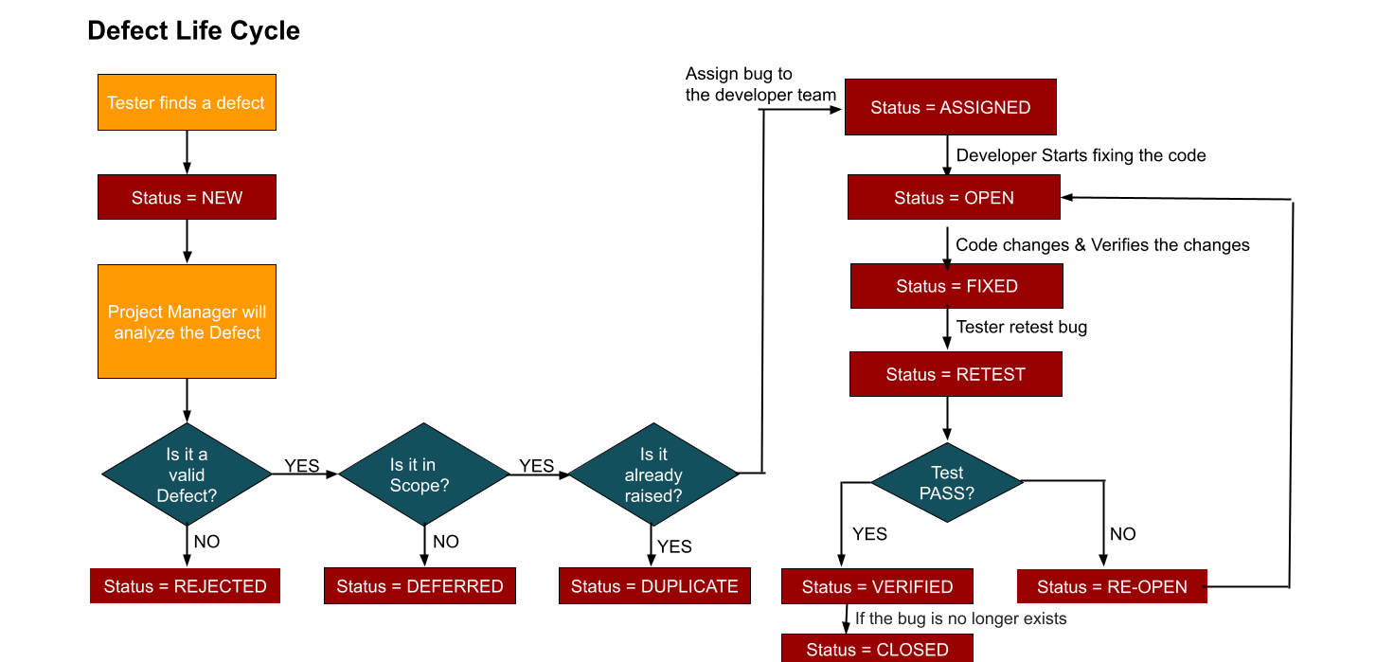**Re-test:** Tester does the retesting of the code at this stage to check whether the defect is fixed by the developer or not and changes the status to "Re-test".

**Verified:** The tester re-tests the bug after it got fixed by the developer. If there is no bug detected in the software, then the bug is fixed, and the status assigned is "verified".

**Re-open:** If the bug persists even after the developer has fixed the bug, the tester changes the status to "Re-Open". Once again, the bug goes through the life cycle.

**Closed:** If the bug is no longer exists then the tester assigns the status "Closed".

**Duplicate:** If the defect is repeated twice or the defect corresponds to the same concept of the bug, the status is changed to "duplicate".

**Rejected:** If the developer feels the defect is not a genuine defect, then it changes the defect to "rejected".

**Deferred:** If the present bug is not of a prime priority and if it is expected to get fixed in the next release, then status "Deferred" is assigned to such bugs.

**20/Test Deliverables**

Followings are the deliverables from QA for pharmacy dept DIUproject:

#### **Test Deliverables before Testing:**

✦ Test Plan

✦ Test Cases

**Test Deliverables after Testing:**

* + - * Test execution report
      * QA report (each sprint)
      * Bug Report

Note: Known issues are well mentioned in each sprint release note*.*

21/Test Plan Approvals

|  |  |  |  |
| --- | --- | --- | --- |
| **Name** | **Roles** | **Signature** | **Date** |
|  |  |  |  |